Name of Race: Dardanup Cycle Race
Location: Dardanup, WA
Date: Sunday 16 May 2010

CONTACTS
Name | Number
Peter Mah | 0438 988 677
Lisa Wood | 0400 197 866

SPR RIDERS
A grade
1) Rylan Fabrici
2) Matt Upton

B grade
3) Scott Betteridge
4) Brendan Nichol
5) Stuart Gee
6) Brett Looney
7) Peter Mah
8) Daniel Hughes - d'Aeth
9) Jarrad Lumbewe
10) Joe Carreno
11) Brodie Waldron - Brown

C grade
12) Carlos De Oliveria
13) David Shailer
14) Michael Thomas
15) Chris Ainsworth
16) Benjimen Berry
17) Toby Brown
18) Jason Cawthorne
19) Daniel Foo
20) Ashley Jacobs
21) Morrison McQueen

Women
22) Davina Summers
23) Rebecca Halliday
24) Lisa Wood
25) Melanie Webb
26) Anna Kauffmann
27) Dianne McAuliffe

RACE DETAILS

Start Times:
Registration: From 8.00am
Racing Start time: 9.30am
At this stage I don’t have the breakdown for each grade.

Race Start/Finish Location:
Dardanup Hall, Corner of Ferguson Road and Little Street, Dardanup

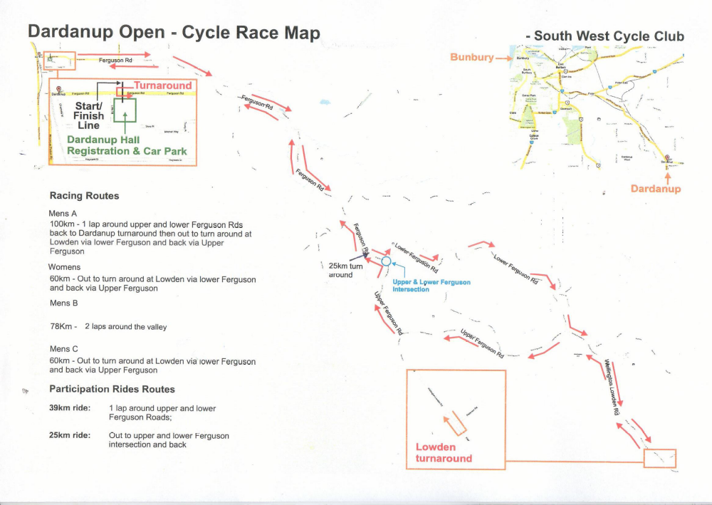

Race Categories

Men's A : 100km
Men's B : 78 km
Men's C : 60 km
Women’s A: 60 km

Equipment Checklist:

Some Items that you may wish to bring with you:

Item | ✓
Racing Licence
Team Kit
Helmet
Bicycle Shoes
Bike !!
Spare knicks & jersey
Plenty of water
Sunblock
Towel
Energy Drinks
Power Bars / GU
Food
Wind trainer (optional)
Extra water
Bike tools & spares
Pump
Personal First Aid kit
Mobile phone
Credit Card

EXTRA WATER
The SPR support team will be available to hand out extra bidons of water from the area in front of the SPR sunshade near the start/finish.
If you think you may need extra water, be sure to bring some filled bottles.
Bottles will be handed out to whoever needs them but if you name your bottle you will be able to claim your own one back again after the race.
NB Be sure to discard your empty bottle before you grab a new one!

Warm-up
Doing a warm-up is important in the preparation for any race and how you do this is individual preference. You may want to bring your wind trainer or use the road.

GETTING THERE:

From Coode St Carpark South Perth to Ferguson Rd, Dardanup, WA

1. |  | Continue on Coode St, South Perth - head towards Mill Point Rd | 39m | 6sec
2. |  | Turn right onto Mill Point Rd, South Perth at Wesley College | 1.5km | 3min
3. |  | Continue along Kwinana Fwy, South Perth | 70.8km | 44min
4. |  | Continue along Forrest Hwy, Ravenswood | 37.8km | 25min
5. |  | Continue along Old Coast Rd, Lake Clifton | 32.8km | 21min
6. |  | At the roundabout - take the 2nd exit onto Old Coast Rd, Parkfield | 6.4km | 4min
7. |  | Continue along Australind Bps, Leschenault | 17.6km | 12min
8. |  | At the roundabout - take the 4th exit onto Australind Bps, Vittoria | 0.2km | 10sec
9. |  | Continue on Australind Bps, East Bunbury - head towards Moorland Av | 0.6km | 23sec
10. |  | At the roundabout - take the 1st exit onto Bunbury Bps, East Bunbury | 0.6km | 24sec
11. |  | Continue on Bunbury Bps, Glen Iris - head towards Ramp | 0.7km | 38sec
12. |  | Continue along Ramp, Glen Iris | 0.1km | 8sec
13. |  | Continue along South Western Hwy, Glen Iris | 0.3km | 25sec
14. |  | Continue along Beverly Pl, Glen Iris | 0.2km | 14sec
15. |  | Continue along South Western Hwy, Glen Iris | 2km | 1min
16. |  | Turn right onto Boyanup-picton Rd, Picton | 7.9km | 7min
17. |  | Turn left onto Ferguson Rd, Dardanup | 0.3km | 16sec
18. |  | Arrive at Ferguson Rd, Dardanup
Sub Total: |  |  | 180.6km | 2hr 1min



