Name of Race: Cyclo-sportif Swan Valley
Location: Herne Hill, WA
Date: Saturday 27th June, 9.00am onwards

CONTACTS – team captains
Name | Number
Jonny Keyes | 0466 153 221
Jordan Brock | 0416 124 625
Nathan Rzepecki | 0412 850 501
Mark Stupart | -
Carol Dowse | 0438 326 463
Peter Mah | 0438 988 677

SPR Team 01
1 Jonny Keyes
2 John Gilbertson
3 Shane Gorman
4 John Phillips
5 Mike Bonner
6 Gregor Urquhart

SPR Team 02 - The Chocolate Canard
1 Jordan Brock
2 Jen Siah
3 Anna Massey
4 Nigel Adcock
5 Raphael Chee
6 Jill Royle
7 Nick Gibbons

SPR Team 03
1 Nathan Rzepecki
2 Darryl Tunesi
3 Katie Lewis
4 Morrison McQueen
5 Ronan Kohn
6 Pete Gill
7 Mike Tan

SPR 4
1 Mark Stupart
2 Ian Waite
3 Greg Raper
4 Declan Coughlan
5 Frank Calcei
6 Doug Heron
7 Mike Round

SPR Developers Team 5
1 Carol Dowse
2 Deb Round
3 Mike Tang
4 Ruth Moyses
5 Jennie Hood
6 Colin
7 Gwyn Stupart

RACE DETAILS

Start Times:
A – 80km
9:01:00 SPR 4
9:04:00 SPR Team 03
9:06:00 SPR 02 – The Chocolate Canard
9:10:00 SPR Team 01

B – 64km
9:34:00 SPR Developers Team 5

Registration, Parking, Toilets & Venue
Registrations will be conducted at the Midvale Speed Dome (the Home of Track Cycling in WA) located on Eddie Baron Drive in Midvale. There is ample parking and toilet facilities at the Dome and access to registrations will be via the rear (eastern) door.

Team Managers/Leaders, please present yourself at the registration desk on Sunday morning to pick up your teams registration pack. The Registration Desk will be open from approximately 7:30am onwards and the Team Managers briefing will follow at 8:15am.

If you need an SPR jersey, they should be available at the SPR tent before the event starts. Please return it after the event so it can be washed and returned to the owner. If you do not have SPR knicks, then a plain black pair is recommended. Remember, it will be cold, so dress appropriately even if it means you cover up the jersey.

All Riders need to make their way from the Speed Dome to the Teams assembly point and start line. This is located at the Herne Hill Primary School in Argyle St Herne Hill, some 8kms north of the Dome. Do not underestimate the distance and time required to get there and, as always, remember to travel safely, not cause congestion or interfere with traffic. Please refer to the map below for route from the Speed Dome to the Primary School.

Assembly Area and Start
Teams are to assemble and be started from the Primary School but the official Start/Finish line, Sign Gantry and timing computer will be located around the corner in Lefroy Ave. The route direction is anti-clockwise, taking in Lefroy Ave, Oakover Rd, Albert Rd, Dalgety Rd, Campersic Rd, Haddrill Rd, Moore Rd, Padbury Ave, Railway Pde, and back into Lefroy Ave to the finish.

**** Riders with Timing Bands (i.e. Team Leaders) please do not cross the start/finish line with your Timing Band prior to the start, otherwise your team may get an incorrect time recorded.****

The primary school toilets will be open and available for use – please respect the condition of these facilities. The first team will commence the Cyclo Sportif event at 9:00am and, as always, there will be a 30 second time gap between each group.
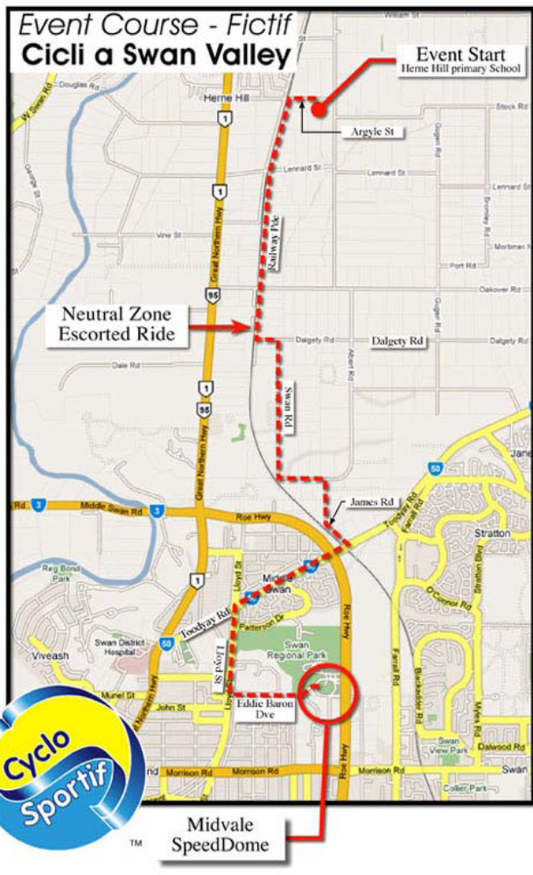

Race Route
Teams in each category will be required to complete multiple laps of the 16km circuit course. ‘A’ distance is 80km (5 laps); ‘B’ distance is 64km (4 laps); and ‘C’ distance is 32km (2 laps). After crossing the finish line for the final time, riders should turn left into Lennard St and go around the block to avoid getting in the way of other teams still completing the event.

Please ensure all team members obey the road rules and follow any instructions from our Marshals and Traffic Controllers. Always be courteous to other riders, teams and officials.
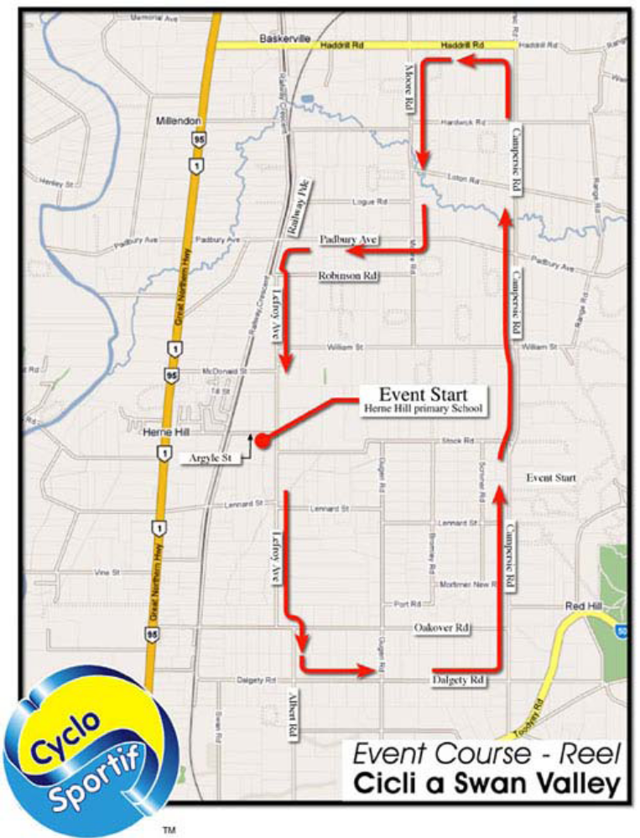

Equipment Checklist:

Some Items that you may wish to bring with you:

Item | ✓
Team Kit
Helmet
Bicycle Shoes
Bike !!
Spare knicks & jersey
Plenty of water
Sunblock
Towel
Energy Drinks
Power Bars / GU
Food
Extra water
Bike tools & spares
Pump
Personal First Aid kit
Mobile phone
Credit Card

How to Race a Cyclo-sportif:

This is a participation event not a race and as such you must stick together as a team. This means if there is a mechanical or flat tyre, then everyone stops. If someone is really struggling, then the group must slow down to keep everyone together.

In order to achieve this, the team must talk...lots. People need to know what everyone is doing. If the rider on the front is going too hard, then yell out to them to go easy. If the person on the back is getting dropped, then they need to yell out, and the second last wheel needs to keep an eye on them as well just to make sure.

If someone is really struggling, then it is more than acceptable for the stronger riders to hang back and physically push them so that they can stay on the wheel. Make sure that the rider that is pushing is both physically able and skilled enough to do it without bringing both riders down.

For maximum speed/endurance, the best formation is single file. Riders can then do a 20-30 sec turn on the front before peeling off and jumping on the back. This is more effective than a roll through as you tend to get more rest in between. Struggling riders can also get more protection this way and don’t tend to disrupt the flow. Towards the end, riders may not be able to hold this formation. It is then time to sort out the strong from the weak and put the strong riders on the front riding two abreast. This then creates the biggest draft window for the weaker riders to hide in. You will do longer turns this way, but it may be down to survival by then.

Be very careful out on the course. There will be lots and lots of other teams out there. You may be overtaking, or being overtaken quite often in the course of a lap. Listen out for groups coming behind and let the rest of the team know they are coming around. If you are overtaking, then make sure you yell out to the oncoming team “bikes back” so they know and can tighten up (hopefully). Don’t forget, this is not a closed circuit so there could be oncoming traffic when you want to overtake. Be aware of that and let the group know if it is unsafe to pass. Better to slow done then be embedded in a four wheel drives bulbar.

Food and drink are very important at an event like this. Take 2 water bottles even if you don’t think you will need them both, as someone else might. Make sure you take food with you (gels or lollies) and make sure you have breakfast. Being nervous and puking up your breakfast is a better option than not eating at all. At least your body may have gained some nutrients first.

Make sure your bike is in good working order. I have often hoped and prayed that my bike would break in a cyclo event. Especially towards the end when you are buggered from going so fast for so long, but in reality, you know that you would be letting the team down.

Make sure you have fun, or at least achieve what the team is capable of. Get together at the start and work out your race plan. Are you going for the best time, or just happy to finish in one piece? The reason these events are so popular is that you get to ride with your friends and it isn’t actually a race.

Come and see us after the event at the SPR tent at the trade show and we should have a coke for you.

GETTING THERE:

From Coode St Carpark South Perth to Eddie Barron Dr, Midvale

Directions |  |  | Distance | Time
Coode St, South Perth, WA
1. |  | Continue on Coode St, South Perth - head towards Whitcomb Pl at Car Park | 0.2km | 35sec
2. |  | Turn left onto Mill Point Rd, South Perth at Wesley College | 1.5km | 2min
3. |  | Veer right onto Way Rd, South Perth | 0.1km | 14sec
4. |  | Turn left onto Canning Hwy, South Perth | 1.7km | 3min
5. |  | Continue along Great Eastern Hwy, Burswood | 8.1km | 12min
6. |  | Continue along Great Eastern Hwy Bps, South Guildford | 5.6km | 5min
7. |  | Turn right onto Roe Hwy, Hazelmere | 19m | 1sec
8. |  | Turn right onto Great Eastern Hwy Bps, Hazelmere | 25m | 1sec
9. |  | Turn right onto Roe Hwy, Hazelmere | 3.7km | 3min
10. |  | Veer left onto Ramp, Midvale | 45m | 4sec
11. |  | Veer left onto Morrison Rd, Midvale | 0.3km | 24sec
12. |  | Turn right onto Gray Dr, Midvale | 0.8km | 1min
13. |  | Turn right onto Eddie Barron Dr, Midvale | 0.1km | 13sec
14. |  | Find a car park.
Sub Total: |  |  | 22.1km | 27min



